AMBER SHUKLA
A8-B3_42
CSE CORE
EXP-3

3 | Demonstrate the use of loops in C Programming Language by implementing following programs:  - Write a C program to print all Armstrong number between 1 to 1000.An Armstrong number is the sum of cubes of each digit is equal to the number itself. For example, 153 is an Armstrong number [153=1*1*1+5*5*5+3*3*3]  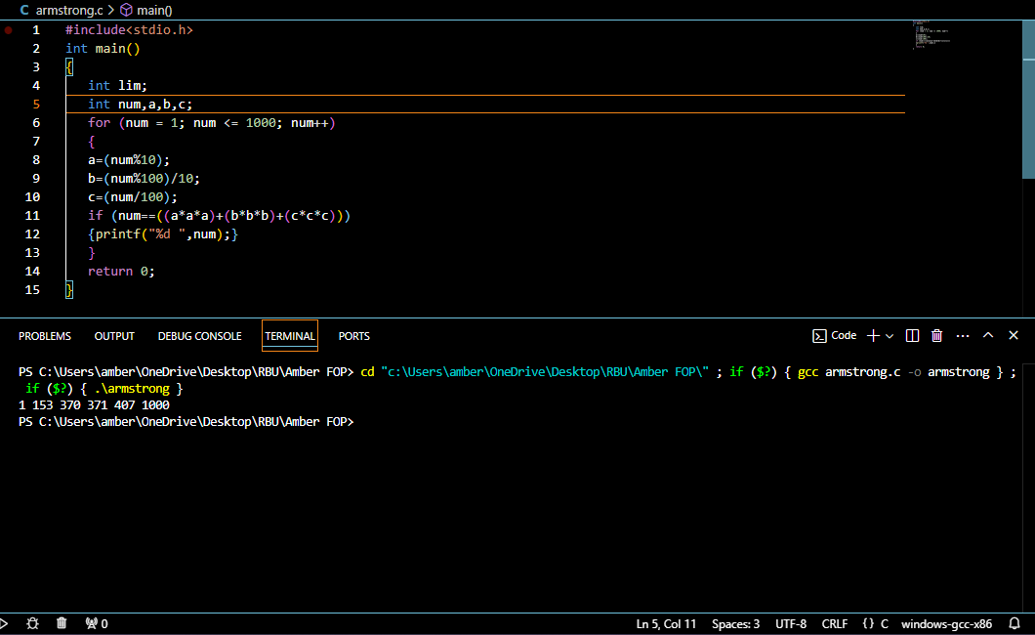  - Write a C program to create following pattern:  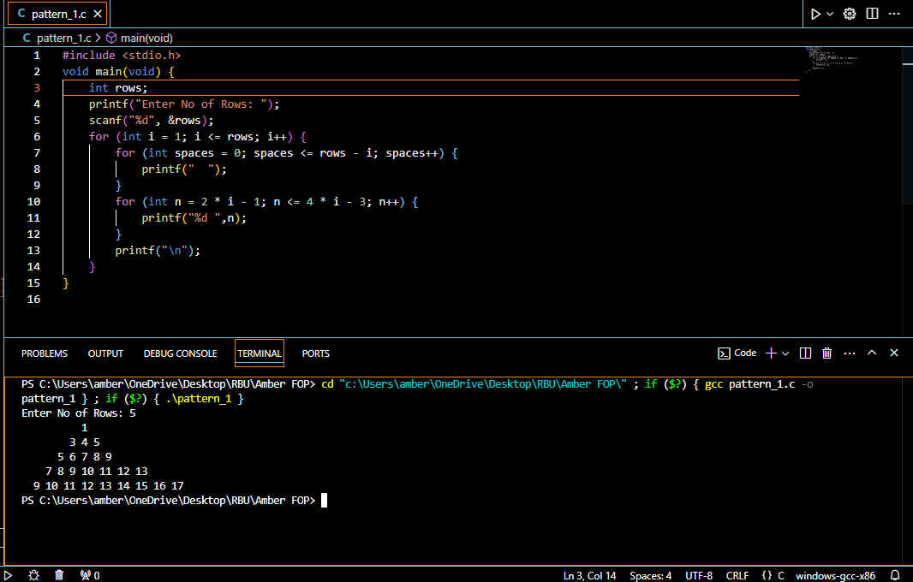  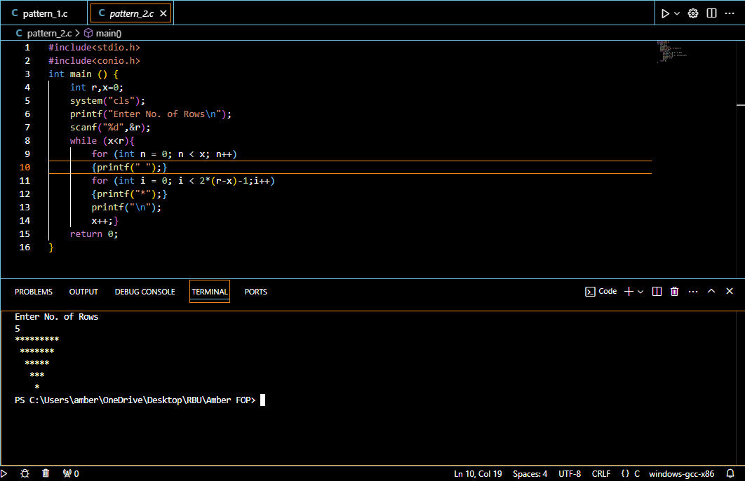  - Write a C program to perform following using Switch -Case  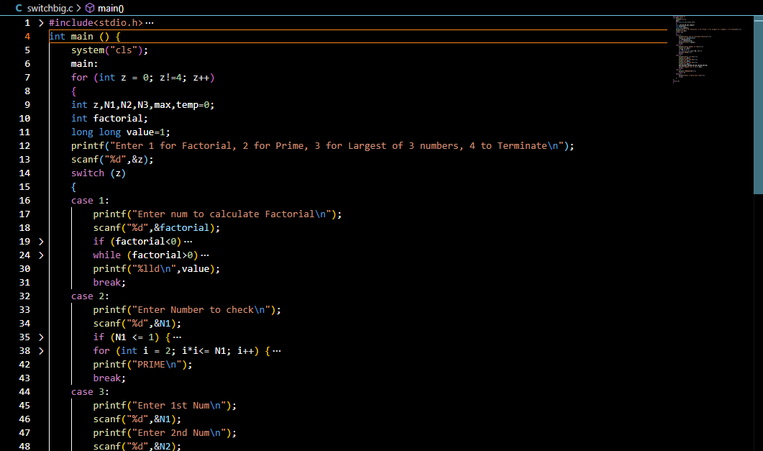  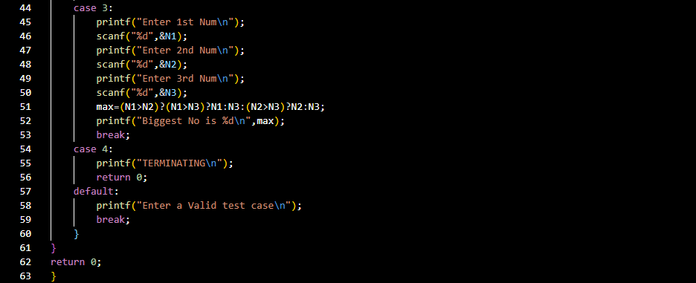  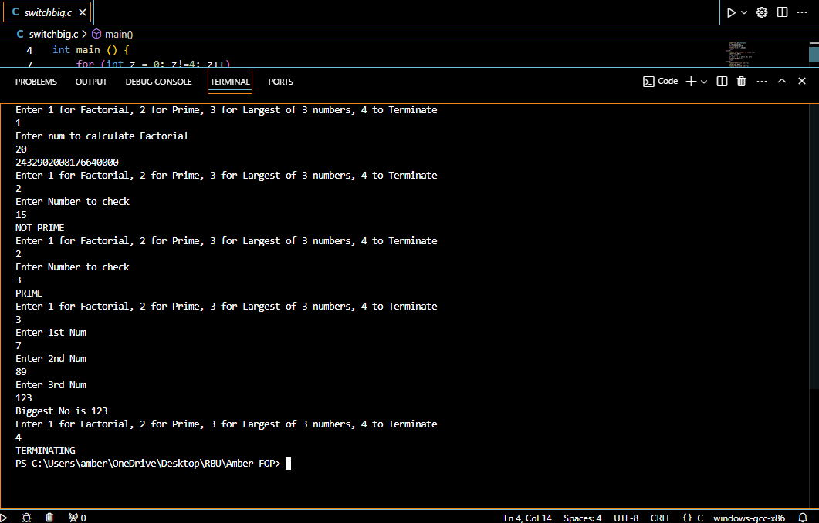 | CO1
   |  |  |  | 1 |  |  |  |  |  |  |  | * | * | * | * | * | *
   |  |  | 3 | 4 | 5 |  |  |  |  |  |  |  | * | * | * | *
   |  | 5 | 6 | 7 | 8 | 9 |  |  |  |  |  |  |  | * | *
   | 7 | 8 | 9 | 10 | 11 | 12 | 13 |  |  |  |  |  |  | *
  9 | 10 | 11 | 12 | 13 | 14 | 15 | 16 | 17
  Choice Code | Action
  1 | To find the largest number among 3 entered numbers using ternary operator.
  2 | To find the factorial of number
  3 | To find the number is prime or not.
  4 | Exit

